Lightning Talk Information –

- If you are planning to give a lightning talk, you are encouraged to attend the poster preparation session, which will also feature lightning talks. The date for the session is listed on the symposium website. The session is designed to best help people who bring a draft of their project/ideas, so consider putting together a draft of your talk/presentation.

- For an overall guide to lightning talks, including a lightning talk on how to give a lightning talk, go here: https://libguides.usc.edu/c.php?g=1384821
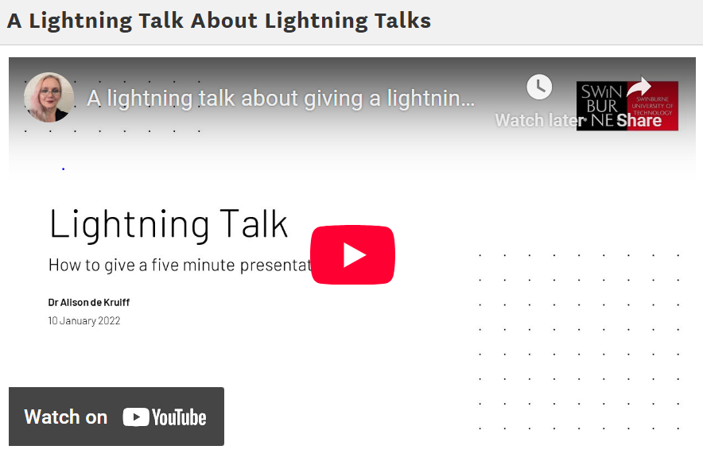

- Talks are limited to 7 minutes, with up to 3 minutes of Q&A, time permitting. (There will also be time needed to set up the next speaker, which could limit Q&A.)

- Speakers will rotate on 10 minute intervals.

- If you have any questions about what a lightning talk entails or whether to do one instead of (or in addition to) a poster, contact the OSU-Cascades Undergraduate Research Coordinator, Matt Orr (orrma@oregonstate.edu).

