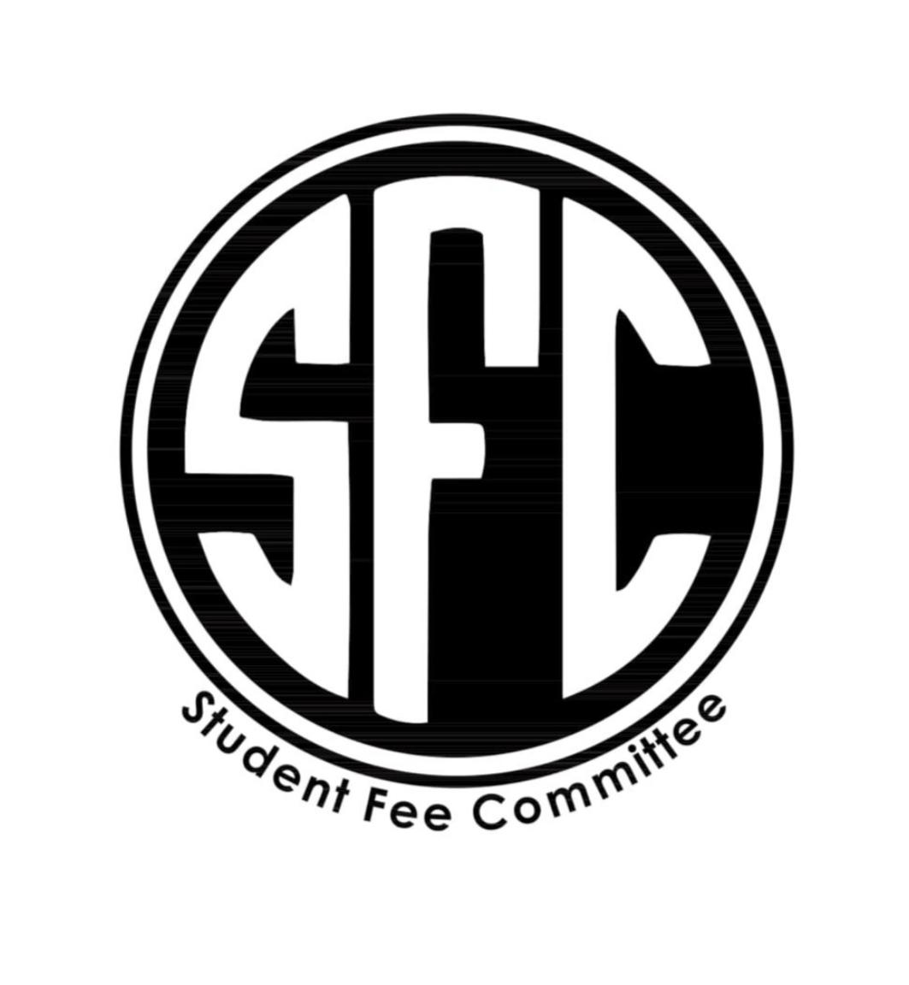
SFC Meeting October 25th 9:00 am-11:00 am

Taylor Graham- Chair
Jordan Jones -Vice Chair
Kurt Wayne-Campus Development
McKenna Wright-Secretary
Kristen Martin- Advisor

9:00- Cascades Solar Car Team:
Alex (President) Morgan (Treasurer)
-review of constitution, mission statement: goal is to educate community about solar energy and the possibilities of solar energy.
-Have 5 executive positions in the club, underneath each position will have sub-positions to help make the tasks more manageable.
-Want to find sponsors and do fundraising events.
-Goal is to get grants to be more competitive with other school’s teams.
-Want to meet every monday, drop in based.
-Budget Request: 1,105.08
-Student Involvement: 15-16 Students
-$500 until they request more, award solar car club 500 dollars from club startup (5-0-0)

9:25 -Hannah Craig- EMDR Therapy Nov. 9th (Second Part):
-Asking 700 dollars, for part two of the training.
-EMDR “Eye movement training”, allows counselors to see negative effects of trauma, and helps treatment for PTSD.
-Taking traumatic memories using EMDR and integrating it with a new prospective.
-Service to campus: Being able to bring knowledge back to the classroom, trickles out to other students, mental health care, more the people talk about it and train for it the better the community will be . Infographic flyer for mental health and trauma.
-Want to do a session about EMDR.
-Motion to give Hannah 700 dollars from Campus Development Fund, Pass 5-0-0

9:50- Special PD Request TRAL (Taylor)
-300 dollars, and a free workshop in December. Much cheaper than corvallis, Corvallis would probably cost about 1,500 dollars.
-Teaching a low ropes course and offered for Juniors and Seniors, they did not realize that they needed to bring in a instructor to help students be taught.
-Move 300 dollars out of Campus Development for TRAL 215
-Motion passes 5-0-0

9:55 Special PD Request- MCcoun Students (Taylor)
-2 students completed all their conferences last year, and then the Master’s Of Counseling changed policies and the students do not need the conferences. Then the Master’s of Counseling program refused to pay back the students. If they fight it they would risk losing the opportunity for the program.
-These students are in need of refunding from the program.
-Want to vote on this later, want to bring them,

10:00 Update-Taylor on CRU
-Taylor and Kristen met with COCC last week, and they are struggling with professional support.
-At COCC, paid leaders have been showing up, misrepresentation, no student leadership within clubs.
-COCC does not have any mandatory leadership positions, not taking responsibility of guests.
-CRU is not getting support, and has also been advertising events for OSU-cascades students, and we are getting to see if there is a legal order we can put on them.
-CRU chartered as an unaffiliated club and they met on campus. Crew official started as a club last year with Jerry Davis as president. Met at the dining hall at Monday’s at 8pm. When Kurt left the president graduated and everyone went their own ways.

10:00- Minutes Approval-McKenna
-Meeting Minutes from October 18th
5-0-0

10:20 Spanish Club-Nathan (president)
-Spanish, Language, and Culture Club.
-Provides practice for speaking outside of classroom, want to have guest speakers come to learn about the culture. Talk about impact of Spanish Cultural Celebrations. Want to do culture parties and have a party at the end of the year.
-Need for speaking among students we need more engagement
-Nathan-President, Christy Miller- Vice President, Graphic Designer-Samantha, Sarah (Zar) Communications Officer. David Ingall- Student Advisor.
-Currently have 34 students signed up. We have had a meeting and have been very successful. Requesting over 500 dollars. Reach out to Bend High.
-Requesting 1,000 dollars for the year, 220 for fall.
-Motion to grant Spanish Club 1,000 dollars from club startup fund. Passes 5-0-0
Closing to Meeting
-Starting meeting with clubs next week
-Motion to close meeting 5-0-0

