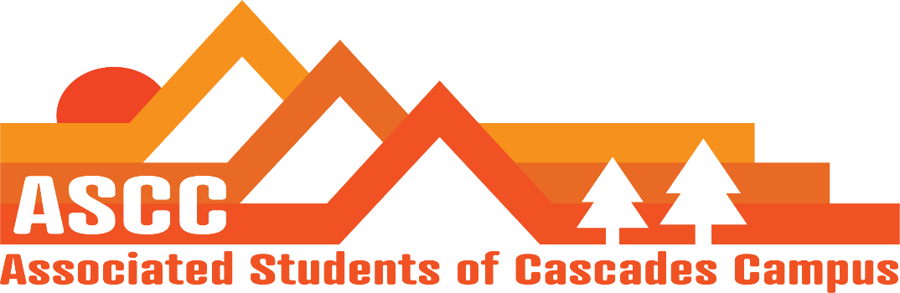
ASCC Meeting 1/16/2019 8:30am
Cole
Cygnus
Reilly
Tessa
Kristen 9:00 am (Advisor)

Cole
Approval of Meeting Minutes from 1/7/2019. Motion passes 4-0-0.

Reilly
OSA membership – Talked with Kristen, Cygnus, and Taylor. Cannot have OSA discussions in office anymore. Not ASCC’s decision if OSA is funded. SFC may discuss OSA
Leadership meeting set up with Becky Johnson. February 5th from 3-4 pm in Obsidian Board Room. Highly encourages all ASCC members to attend meeting.
Have student ideas for Student Success Center. Jeffery made a mock student success center and the plans were given to Kelly Sparks.

Tessa
Ordered name tags and new business cards
Designed an info flier for all areas of Student Life.

Cole
Zola from Veterans services wishes to take our Coffee Machine for Veterans Coffee hours. Inform Zola however that the machine is on loan as the machine is paid with student fees. Will stay in her office. Vote to approve lending coffee machine to Zola for student Veterans services. Motion passes 4-0-0. Coffee Machine will be stored in the office of Zola Nkansah in Tykeson Hall Room 106-B.
Cygnus
OSA will be conducting training for student leaders.
Leadership training day
- Intro to Social Justice and Facilitating Safe & Inclusive Spaces
- Running Effective Meetings
- SFC - Intro to OSA
Date is not set yet.
First Class rap of the term today.
Planning on sending out e-mails to Oregon Legislators today.
February 7th and March 5th Lobby Days

Kristen
Had focus group for the Student Success Center yesterday, January 15th. Majority of SFC members attended. Cole and Cygnus attended along with a few other students. About 10 in all.
Would like to have the same amount of new students attend the next focus group.
Working on finding out what is going to be put in around the SSC so that students can make better decisions on what they want to see in the building.
Can work on workshopping outdoor rec ideas separately since those things can be built sooner than the building itself.

Important Dates
January 16th – Club Fair 12-2 pm
January 21st – MLK Day of Service 8:30am-2:30pm
January 23rd – Budget Town Hall 4-5 pm
January 26th- OSA Board Meeting
January 30th – Tuition Scenario Town hall 11-1pm

Vote to end meeting at 9:22 am. Motion Passes 4-0-0.

