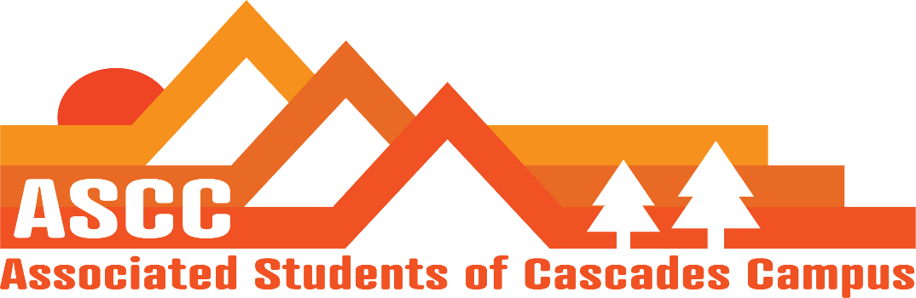
ASCC Meeting 1/23/2019 8:30 am
Brian
Cole
Reilly
Taylor
Tessa Kristen (Advisor)

Cole
Meeting Minutes from 1/16/2019. Vote to approve meeting minutes. Motion passes 5-0-0.

Reilly
Don Francisco’s – called last week. Have been trying to get in touch with ASCC. Gave the owner e-mail. Informed the owner that Zola is using the machine for Veterans Services. Will be getting more coffee and offer machine maintenance from Don Francisco’s.
Priorities for the February 5th meeting – meeting with Becky Johnson and Jane Reynolds.
Give the sustainability coordinator update. OSA membership update. Support program update. Food pantry and childcare subsidy update. Graduate student position on ASCC. Grant proposal. Student Success Center update. Update of all leadership training. ASCC rebranding, Lobby efforts that have been made. ASCC budge update. Club update. Cole’s student life survey update.
Elections Committee – Time to put elections committee together for next year’s ASCC team. By end of next week is when the committee must be established. The first and second week of Spring Term is campaigning. Week three is elections week.
ASCC Guidelines and Expectations Overview.

Taylor
SFC – Budget Meeting 4-5 pm. Kelly Sparks gave SFC a spreadsheet that allows working with funding. $630,000 contribution is expected for the Student Success Center. SFC will work with
Taylor and Cole went to Planned Parenthood and got information as well as safe sex materials to start up the safe sex initiative on campus. Working on purchasing containers for materials. Planning for condoms, dental dams, lotion, band-aids, toiletry kits, tampons, cough drops, hand sanitizer.

Brian
Food Pantry update – have had 4 new students use. 5 students return. 9 students total on 1/22/2019. Dennis Lynn from HDFS wants to get his students in the families and poverty program involved with food pantry to help out as well as do surveys. Made new sign for food pantry hours. Thinking about putting up a small whiteboard for future use instead of a paper poster. Made an additional resources flier for local food pantries in the Central Oregon community. Trying to get a donation box over to the GRC.
Child Care Subsidy update – 7 childcare subsidy apps tuned in. Maybe getting nine. Deadline is this Friday, 1/25/2019.

Tessa
Name tags are here.
Neighborhood board meeting last week. Event with university, board, and community members for learning how to make the community fire safe. Asking for student leaders to be present to work the event. May 11th, 2019 is event date.
Working with Events Council on their new logo.
Having met with Bend Food Project.
Will order Long Board Louie’s
Important Dates
January 23rd (today) – Budget Town Hall
January 30th – Tuition Scenario Town Hall
February 7th – Lobby Day
March 5th – Lobby Day
April 17th – All University Lobby Day

Vote to end meeting at 9:27 am. Motion passes 5-0-0.

