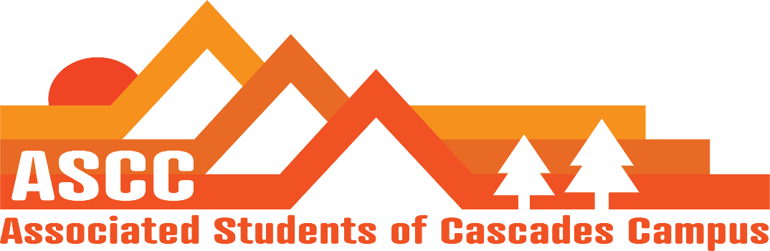
ASCC Meeting 1/7/2019 12:00pm
Brian
Cole
Cygnus
Reilly
Taylor
Tessa
Kristen (Advisor)

Reilly
Current meeting time does not work. Wednesdays 8:30-9:30 am. Motion passes 6-0-0. Beginning next week.
Student Success Center (SSC) Town Hall January 9th. 5-6pm
SSC Brainstorm from 12pm-2pm January 15th
Cub Fair January 16th 12pm-1:45pm
Budget Town hall January 23rd. 4-5pm
Tuition Scenario January 30th 11am-1pm
Sign-in and sign-out sheet for office

Taylor
Setting the fee for next year. Putting out a memo to Becky Johnson and Kelly Sparks. Working on setting the student fee for next year.
Working on getting Safe Sex Initiative in the works

Cygnus
Sent out Group Me survey for Lobby Day planning for the rest of the academic year.
OSA meeting on January 26th.
Northwest Student Leadership conference in February 16th-18th.
Brian
Updated Child Care subsidy forms for Winter Term. Edited copy has been sent to Tessa. Reached out to the seven students from last term.
Has e-mailed Safeway and Walmart and other grocers for a Food Pantry donation partnership.
Still waiting on librarian for information regarding participation during library hours from Fall Term.
Tessa
Working on getting name tags for lobby days.
MLK Day of Service Group
Club schedules are posted online
Cole
Student Survey total responses was 55. Gave a breakdown summary to Reilly and Kristen
Review of meeting minutes from 11/27/2018. Motion passes 6-0-0.
Kristen
Students are now fully in charge of setting the ‘big buckets’ of student fees.
Creating calendar for Student Life office for listings of all event dates.
Shared student survey with Jane and Operations Council.
Club involvement. 120% growth. 374 students involved. 22 chartered clubs. 341 out of the 374 were unduplicated. Rock Climbing Club is most chartered (180 students; 124 are active). 566% growth in active membership for club sports.

Vote to end meeting at 12:32 pm. Motion passes 6-0-0.

