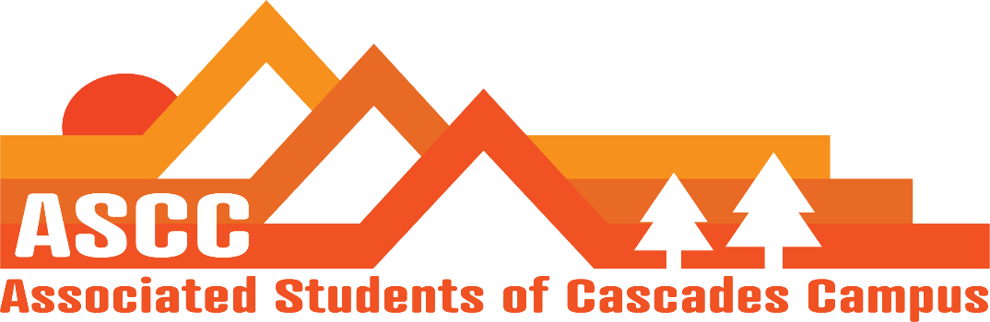
ASCC Meeting 10/23/2018 6:45 pm
Brian
Cole
Cygnus
Taylor
Tessa
Kristen (Advisor)
McKenna (SFC) Executive Session
Kurt (SFC) Executive Session
Jen (SFC) Executive Session

6:45 pm – Taylor and Kristen
Motion to hold an executive session with ASCC and SFC. Motion passes 8-0-0

7:42 pm – Cole
Approve Meeting Minutes from 10/16/2018. Motion Passes 5-0-0.

7:46 pm –Tessa
Will be sitting on neighborhood board for the campus expansion.

7:47 pm – Brian
Child care. Total 7 applications. The total allocation will be $2,550 for the 7 applications.
Apps were divided up upon credit hours and money spent on childcare.
Found an Excel sheet from former child care app history. Can use it to get Women’s Circle Grant
Food Pantry. 9 students today. 5 new and 4 returning.

7:50 pm –Cygnus
77 GOTV guides turned in. Will work with Cole to get Voter Registration completed.
Taking 6 students to OSCC at WOU.
Phone Banking. Gained two volunteers. Continuing this week and next week

7:54 pm – Cole
Budget update.
$23.03 spent on materials for Trunk or Treat event on campus on Halloween

7:56 pm – Kristen
Roughly $100,000 will be gained and given to SFC.

Vote to end meeting at 8:00 pm. Motion passes 5-0-0.

