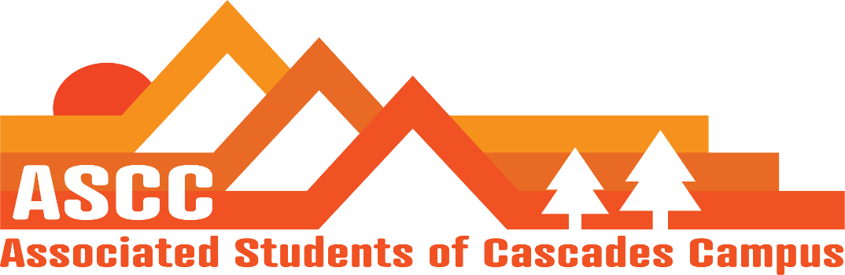
ASCC Meeting 11/13/2018 6:45 pm
Brian
Cole
Cygnus
Reilly
Taylor
Tessa
Kristen (Advisor)

Cole
Approve meeting minutes from 11/6/2018. Motion passes 6-0-0

Reilly
President Updates
Vote on M.O.U with ASCC and OSA. Motion passes 6-0-0
Gearing up for Lobby Prep. Wok on creating an outline with the students for Lobby Day. Will provide some snacks for Lobby Prep Day.
End of Term 1:1’s. Check-in set-ups with Kristen

Taylor
SFC Update
Position changes within SFC. Out two positions. Club coordinator and Treasurer at end of the term. Taylor will run advertising November 29th-30th for the two vacant positions. Will move committee Secretary to Club Coordinator.
Started up club training. Presidents meetings and treasurer meetings.

Cygnus
Legislative Update
OSCC is this weekend. Four students including Cygnus.

Tessa
Clubs have been asking to put club meeting times on Beaver Tracks. Have had to respectfully decline to put them on.
Considering creating a club resource document/flier for the future.
Will redesign layout for Beaver Tracks for next term to create a separate section for club information.

Brian
Made fliers for a food drive for Food Pantry. One flier is to address the drive. The second flier contains a list of items for people to donate.
Working with inside sources
Julia, COCC Internal Affairs coordinator can meet with Brian to address food pantry cooperation.

Cole
Created the Student Survey. Includes questions from ASCC, Programming Board, SFC, and Cascades Adventures. Will go out to undergrad and grad students. Created QR Code to be scanned for online survey.

Kristen
Advisor Update
Basic Needs Statement for a potential add-on for student Syllabi
Hours and working in the office over the winter break. Create a scheduling system with Kristen if needing to put in work over break.
Winter Safe Zone training for ASCC-SFC. December 12th 8am-11am

Vote to end meeting at 7:28 pm. Motion passes 6-0-0.

