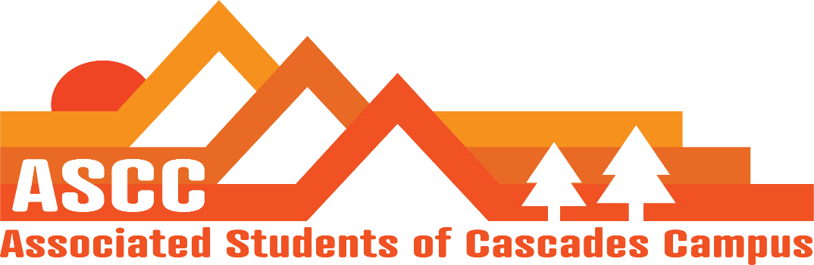
ASCC Meeting 11/20/2018 6:45pm
Brian
Cole
Cygnus
Reilly
Taylor
Tessa
Kristen (Advisor)

Cole
Review of Meeting Minutes from 11/13/2018. Vote to approve meeting minutes. Motion passes 5-0-0.

Reilly
Lobby Prep. Total of six students showed up for prep day. Possibly 16-17 students willing to come and lobby.
End of Term reminders. Set up one on one times with Kristen.
Vote on hours for Winter Break. E-mail Kristen. Vote to approve half-time hours over winter break with condition that hours are discussed with Kristen. Motion passes 5-0-0.
Constitution Bylaws additions. Added violation of the Student Code of Conduct in the Disciplinary Action Section of the Bylaws. Will vote later.
Transition Document Overview.

Taylor
Ed Ray Visit overview. The meeting was with Ed Ray, President of University and Becky Johnson, Vice-President of the campus as well as community leaders to discuss lobbying for Student Success Center funding.
Co-Curricular Counsel Meeting Update
SFC update - Moved McKenna to club outreach coordinator. Elsie Charles will work as club event coordinator.

Brian
Child Care Subsidy update. Students have their subsidies for the term.
Food Drive update
Library Update. May sponsor pizza night on Sunday. Most tutors will be present on that day. Vote to approve funding for pizza sponsorship. Motion passes 5-0-0.

Tessa
Chili Cook-off
Neighborhood Board update. Century West Neighborhood Association. Tessa will be representing the students who live on campus. Want to host an event for the students living on campus.

Kristen
Advisor Update. Met with Cygnus and Jock to discuss lobbying. Trying to meet with the two new area representatives to get to know them and for them to get to know the students.
December 13th. Lobby Day. Begins at 9:00 am

Vote to end meeting at 7:42 pm. Motion passes 5-0-0.

