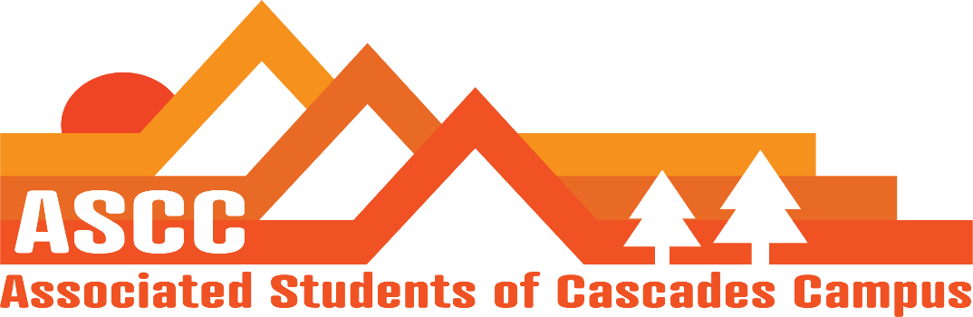

ASCC Meeting 11/6/2018 6:33 pm
Brian
Cole
Cygnus
Reilly
Tessa

6:45 pm – Cole
Approve meeting minutes from 10/23/2018. Motion passes 5-0-0

6:36 pm - Reilly
Talked with Tessa to move the office around. Wanting to create more working space by moving desks and computers around. Run a work order past maintenance. Put in some time over Winter break to work on rearranging the office.
Talked with Kristen on changes to University Syllabus made by campus professors. Wanting to put ASCC services in the syllabus.
Draft language for a Code of Conduct for the ASCC Bylaws.
Lobbying Workshop on November 19th. 12:30pm-1:30pm. Provide students with information on what to expect during Lobby Day.
MOU is finished. Will be sent out to all ASCC members and will be voted on next meeting.

6:43 pm - Brian
Did not open Food Pantry today. Key was absent from lockbox.
Partnerships are on Kelly Sparks Agenda. Waiting for her to get to it.
Kristen went to talk to the Business Office on Child Care applications
Will help out with a dead week for the Librarian. Planning on providing some snacks for dead weak.

6:50 pm - Cole
Budget updates/considerations for future paid positions.
Possible Grad position. Looking into possible payment for 2 OSU - OSA reps. possibly create a split position for supporting the Director of Legislative and Advocacy Affairs.
Created a possible payment plan for 2 OSA reps. Looked at time commitment for their roles and used Oregon State minimum wage as hourly payment. OSA meetings. Team Meetings. Travel for OSA meetings. Total being considered is $1350.

7:00 pm – Cygnus
GOTV. Reached out to 248 students, only 32 under the goal. Went to all classes that were allowed to go to.
Working on a conference agreement for OSCC. Provide information for students who come on the OSCC trip. Reimbursements, etc.
Working with Cole on reimbursements and the conference and travel budget for the trip.
Working on organizing training for OSA reps.

Vote to end meeting at 7:16 pm. Motion passes 5-0-0

