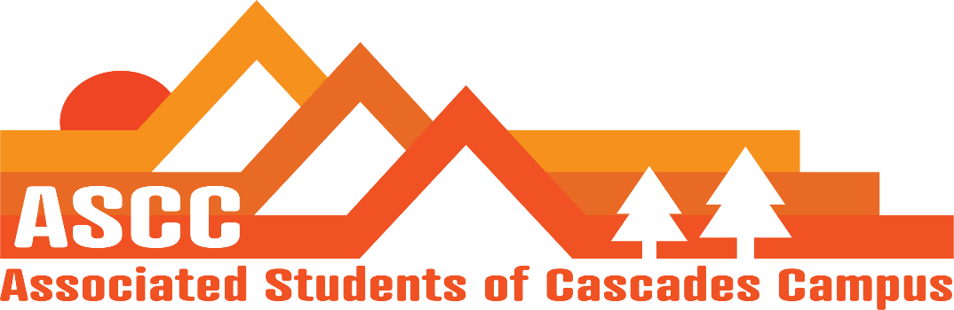
ASCC Meeting 2/20/2019 8:30 am
Brian
Cole
Cygnus
Lynnea
Reilly
Taylor
Tessa

Cole
Vote to approve Meeting Minutes from 2/13/2019. Motion passes 7-0-0.
Reilly
OSA on campus next week. Can ask questions on proposed bills that are in the works. Begin to have bi-weekly phone calls with OSA.
Taylor
Asking ASCC members for removing or keeping the trees out in the Tykeson courtyard. People wish to play soccer. Leave the trees
Safer Sex will become Safer Living. Will inform that we will utilize the caddies over the cabinets and instead, ask for admissions to pay for the cabinets. Will meet with Admissions.
Professional development funds in SFC have been dropped to $700 limit from $1,000.
Chartered Golf Club
Brian
10 students in the last week. 2 new students. Got 501 non-profit number. Can now partner with Bend Food Project and other organizations.
All Child Care subsidy students have been given their funding.
Tessa
Want to update the website for the Safer Living program. Put a QR code link for information for Safer Living resources. Offer outside resource information and links to all products that ASCC offers within the program.
Update ASCC positions elections/selections page
Add Lynnea Fredrickson on the ASCC team page
Constitution page updates
Have a conversation with students coming into the office when SFC/ASCC members are not in the office. Concern for providing accurate information to students and possible theft.
Lynnea
Conversation with Jock Mills. Discussed details for March 5th Lobby Day. May need to recruit different students to attend and get students that represent certain constituents’ areas. Discussed the rubric for HEC. Made a new talking points page. Talk on being unified for funding. The page consists of Higher Education Alliance; shows the university and community colleges that are all in support for a state budget that funds Oregon’s higher education system. Discussed the Oregon Promise with Jock.
Cygnus
OSA will be on campus next week. Proposing a trainings, provide an all student list for club leaders to attend training. Social activism training. Leadership training for recruiting future leaders and working on leadership skills. Propose Safe space training on Friday. Propose rolling out the new Safer Living program at a one of the trainings.
North West Student Leadership Conference. Campus representatives Fernando, Justice, and Julia are in ASCC meeting attendance to go over their experience at the conference. NWSLC is under new leadership temporarily. Discussed new vision for OSA.
Fernando: involvement in conferences have been overall positive. Does not know ASCC’s stance on OSA and wishes to know more. Informed Fernando that ASCC does not discuss OSA membership. Can discuss what is going on in OSA. OSA can sit in on SFC/ASCC meetings. OSA funding was cut at OSU-Corvallis. Signed an MOU with OSA for attending campus. Did caucus training. Lobbying simulation.
Justice: Lobbying day was the highlight. Talked to several representatives. All reps were for funding higher education. Attended immigration injustice training. Lobbying 101. Lobbying simulations.
Cygnus put in letter of resignation.

Julia: Lobby simulation/Lobby 101. Environmental justice. Enjoyed the conference.

Important Dates
March 5th: Lobby Day @ 6am-5-pm
March 6&7: Elections information session @ 1pm
March 15: Elections filling deadline @ 5pm

Vote to end meeting at 9:23 am. Motion passes 7-0-0.

