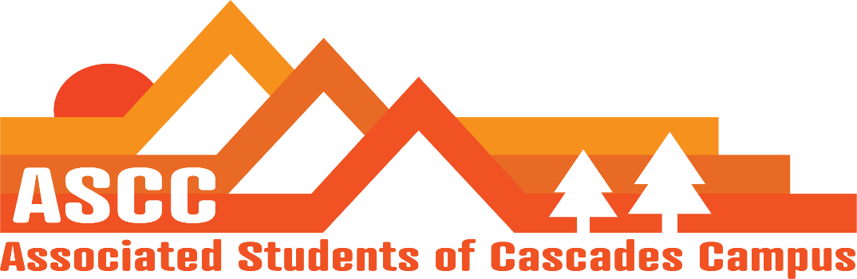
ASCC Meeting 3/13/2019 8:30 am
Brian
Cole
Reilly
Taylor
Tessa
Kristen (Advisor)

Cole
Vote on meeting minutes from 3/6/2019. Motion passes 5-0-0.
Reilly
Elections schedule – All elections paperwork is due this Friday. Tessa will be working on headshots for applicants. Currently 8 students came to the info sessions last week.
Schedules for next term – turn in schedules this week. Mondays and Wednesdays appear to be the best days as of right now. No meeting next week (Finals Week)
Vote on job descriptions – wrote up job descriptions for Student Inclusion Coordinator and Graduate Student Affairs Coordinator. Motion passes 5-0-0.
Taylor
SFC update – Chartered Gardening Club. 26 chartered clubs on campus. April 26th will be Budget Hearing for Spring Term.
Brian
Food Pantry update – Brian and Cole went to stores to try and get donations/partnerships. Fred Meyer denied request due to current partnerships. Safeway said yes, but will not be a regular basis donor. Went to Albertsons, waiting for response. Bend Food project denied request due to the needs of other organizations that they are trying to meet. Plan on reaching out to Neighborhood Impact for a possible partnership due to the fact that most stores/organizations work with them.
Lynnea (Reilly)
Legislative Update
Testimony for Saturday/Plan – 2-4pm in Redmond for Ways and Means. Reached out to 90 students. Hoping to get at least 50 students and to get some testimonies from students in regards to OSU-Cascades.
Recap of weekends OSA call – Not a good call. Discussed how students wish for the organization to be improved upon. Discussed how the organization may be dead in roughly five years if issues within the organization are not changed. Knocked down proposals that OSU-Cascades wants most.
Tessa
PR update – Working with candidates for ASCC positions. Will publish a list of applicants that will run for office. Feature names, bios, pictures, etc.
Need to decide when to open up the new job applications. Propose opening it for week 2 of Spring Term. Close week 6. Application open April 15th. Applications due April 26th. Interviews by May 8th. Decisions May 10th. Have students reply by May 15th.
Propose May for the transition retreat.
Kristen
Advisor update
Received copy of MoU for OSA from the Corvallis campus.

Vote to end meeting at 9:37 am. Motion passes 5-0-0.

