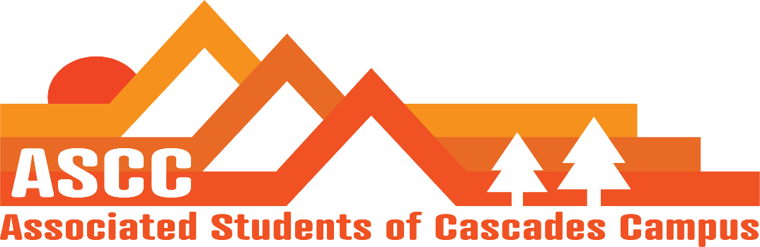
ASCC Meeting 3/6/2019 8:30am
Brian
Cole
Lynnea
Reilly
Taylor
Tessa
Kristen (Advisor)

Reilly
Discuss possible graduate position for next academic year. Consider opening up a six hour graduate position on ASCC to represent graduate students. Put off voting for new positions until next week’s meeting.
Provide Spring Term schedules for ASCC meetings for Spring Term
Day in Corvallis Spring Term. Corvallis student government would like ASCC to come visit the campus. A Friday visit would be best day to visit.

Taylor
Safer Living first week update – Been having issues with stolen bottles. Need to inform student in some way to not take the hand sanitizer, hand lotion, or sunscreen bottles. Will watch for the first week. Go from there.
Budget hearing for Spring Term. Trying to ensure a smoother transition then last year.

Brian
Child care subsidy. $2590 left over. Working with $200-$350. Will remain a little below budget if we are to get the same amount of applicants. Consider stating the lowered max to the students for the next application.
Bend Food Project is going to go over our tax ID number and get back to us.
Reach out to Neighborhood Impact
Food for Less will take about three weeks to a month to respond to our request.
Cole
Vote on overview of meeting minutes from 2/20/2019. Motion passes 6-0-0.
Tessa
Beaver Caucus meeting. Want a letter of support for the ways and means hearing on March 16th. State wide having a lobby day on March 18th. OSU Day is on April 17th.
Ordered materials for Lynnea. Business cards, etc.
Diversity Week meeting. Discussed ASCC and club participation. Consider food insecurity information. Discussed diversity in politics workshop. Date is 22nd -26th of April.
Lynnea
March 20th. Lobby Day make up. March 5th Lobby Day was cancelled.
OSA meeting is this week.
Ways and Means Roadshow. OSU main campus are not interested in being involved. Will go to Portland campus mainly. Jock Mills wants over 50 students for Redmond Hearing. March 16 from 2-4pm at Redmond Expo Center. Try and push for extra credit if students attend the event. Consider providing food.
Discussed Kaylee’s Law with Jock Mills – Being pushed at the capitol. Being worked on more.
Discussed Governance Bill/Hearings with Jock Mill – Bill that would work for student governments to be in support or opposition on ballot measures. Student governments cannot currently do that legally as of now.
April 4th tuition meeting. No one is raising tuition over 5% now according to Jock.

Kristen
Talked with potential Grad rep. willing to volunteer their time for next term.
Thursday, March 14th is discussion on keeping or removing computers in computer lab.
Keeping the trees at the front of Tykeson Hall is currently favored over removing them.

Important Dates:
March 6&7 – election sessions @ 1pm TYKE 107
March 16 – Ways and Means Roadshow
March 22 – End of Winter Term
April 4 – Bend Woman of the Year Award Ceremony
April 17 – All OSU Lobby Day

Vote to end meeting at 9:38 am. Motion passes 5-0-0. (Reilly left meeting at 9:00am)

