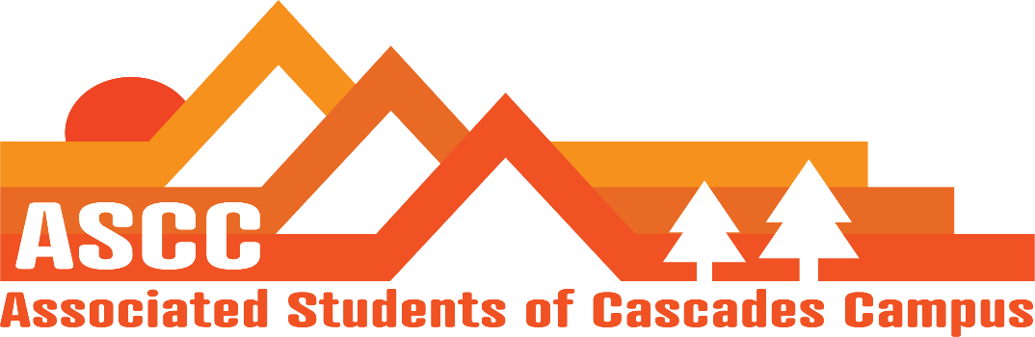

Meeting 4/19/2019 3:00 pm
Brian
Cole
Lynnea
Reilly
Tessa
Kristen (Advisor)

Cole
Review meeting minutes from 4/10/2019. Vote to approve meeting minutes. Motion passes 5-0-0.
Reilly
Town Hall – set date. 3:30-4: 30 pm May 16th town hall.
Elections are now over.
ASCC Selections info. Selections applications are now open. May have to extend the end date. Working on selections packet.
SFC update – been having meetings with Kelly Sparks on student success center. Considering using some of the money to build upon the outdoor space for students to recreate.
Budget hearings are next week on April 26th.
Brian
Child care subsidy. 8 total applications turned in. Will give awards next Tuesday.
Food pantry – more students coming with the new hours.
Diversity week. – Prof. Lynn will be facilitating. Representation from Warm Springs. Representation from Neighborhood Impact. Budget is at about $320 right now. Catering through Olive Garden. Changed from Tuesday to Thursday from 12:30 pm – 1:30 pm.
Farmers Market wants to get set up this term
Tessa
Fire Safe Event May 11 – Open positions for students to fill. Shifts start from 9:30 am -2:00 pm
Lynnea
The turnout from Lobby Day – 12 students attended lobby day.
Jock wants students from every district area that we have on campus to sit on the Senate floor to address tuition struggles.
OSA will be here for Diversity Week. Two workshops – Intro to OSA. History of student Leaders in Oregon. Last workshops are addressing marginalized communities.
Kristen
Advisor update
Diversity Week events list is drafted up. April 22-26.
A grad student is interested in applying for the Graduate Affairs Coordinator for the next academic year.
Important Dates:
April 22-26. Diversity Week
April 26: Budget Hearing
May 6: State of the University @ 6 pm @ Bend River house
May 11: Fire Safe
May 18: Pole, Pedal, Paddle
May 23: Research Symposium
May 31-June 2: TBD Transition Retreat
June 6: Leadership Banquet
June 14: Senior Send-Off
June 16: Commencement

Vote to end meeting at 3:18 pm. Motion passes 5-0-0.

