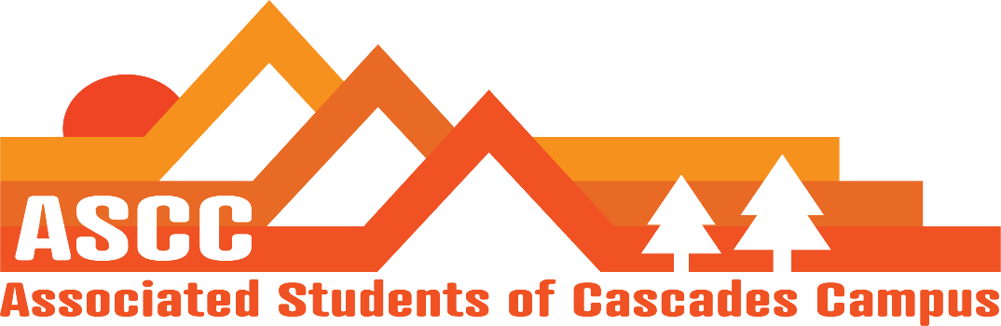
Meeting 4/24/2019 4:00 pm
Brian
Cole
Reilly
Lynnea
Taylor
Tessa
Tori (OSA)
Kristen (Advisor)

Cole
Review meeting minutes from 4/19/2019. Vote to approve meeting minutes. Motion passes 6-0-0
Reilly
The team moving forward/rest of the year outlook.
Elections – putting together a new certifying committee to address allegations and complaints from this year's elections process. Group of up to four students that are not heavily involved in student life.
Updating Constitution and Bylaws around elections campaigning. Will vote on changes next week. Language includes eligibility for students to run.
The application deadline will be May 3rd for Selection.
Taylor
SFC update – Budget hearing is April 26th.
Discussing rec ideas with Kelly Sparks for the outside of the student success center including disc golf, rock wall, etc.
Brian
Child care subsidy info – 8 applications. The budget was divided by eight from the $2590 budget for a total of $323.75 per student. Payment request forms will be submitted this week.
Diversity Week event info – food has been ordered. Budget is now $270 for the inclusion of utensils and plates. E-mailed speakers for the event. The matching donation has already been met. Donations have been submitted to the business office and the funds can now be used to purchase food for the food pantry.
Worked with Tori on letterhead for monetary donations from businesses for food pantry donations. Brainstormed sponsorship levels for donations such as social media posts for thanking sponsors. Expand food pantry banner to include sponsor logo.
Cole
Oregon State University, State of the University address update. Seven seats proposed as of now for the 8 seat table sponsorship.
Lynnea
Jock trying to get students from represented districts on the Senate floor is currently underway.
SB731. Bill on student government has passed in the Senate.
Kaylee’s Law passed 29-0.
SB958A. Dreamer funding for a masters degree is still sitting on the ways and means.
May 14th, OSA at the Capitol
OSERA, May 11th
Tori
OSA on campus
Diversity Week workshops - Lobby 101. History of Student movement.
OSERA Tabeling in Beaver Dam
Talking with Oregon Legislature on tuition. Legislature feels as if students have not been as vocal about tuition.
Kristen
Certifying committee. Students will get pulled quickly. 2 students have said yes, finding 2 other students to confirm.

Vote to end meeting at 4:54 pm. Motion passes 6-0-0.

