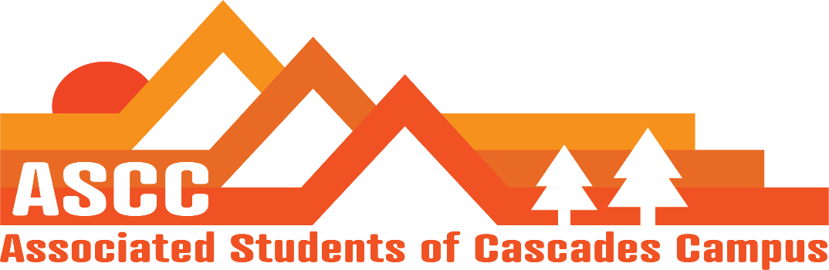
Meeting 4/5/2019 1:53pm
Brian
Cole
Reilly
Lynnea
Taylor
Tessa
Kristen (Advisor)

Cole
Review of meeting minutes from 3/13/2019. Motion passes 6-0-0.
Reilly
Elections – Week three is last week for campaigning. Posters can still be up, but no events/meetings. Open forum will have pizza for students. Will print out a brochure of candidate statements. Meeting with elections committee to discuss a more improved method of working with candidates for campaigning.
Transition Prep. – Get Job binders together to go over information with the new ASCC members when the transition retreat comes up. May 31st-June 2nd will be the preferred date range. June 6th will be Leadership Banquet.
Consider changing the ASCC meeting from today to Wednesday at 4-5 pm starting April 10th. Motion passes 6-0-0.
Taylor
SFC update
Meeting time is same time last week from last term. Chartered Paddling Club on Thursday. 27 chartered clubs total on campus. PD applicants will be next week. April 26th will be budget hearing
Brian
Timeline for Child Care subsidy applications. Updated application. Due April 17th at 5:00pm. Handed out 2 new applications. Total is still at 10 applicants. Former applicants have been e-mailed for possible renewal.
Food Pantry update. 12 students total this week. Today was not popular (only 2 students). Run a survey for possible times.
Talk to Oregon Food Bank, the statewide food bank.
Diversity Week. Propose a food insecurity event. Propose a forum/food drive/a farmers market with gardening club. Hold a raffle for students that donate food.
Cole
State of University Table. Propose $750 package for the State of the University event. Can take out of miscellaneous budget. Currently $3,046 left. Will still have almost $2,300 left over in the budget if the table package is purchased.
There is a smaller, $325 package that can be purchased.
Purchase the $325 table package for the State of the University on May 6th. Motion passes 6-0-0.
Lynnea
OSA on campus next week – Have not replied for confirmation.
Government Relations call updates – Tuition Freeze Bill has died in Committee. Position on Student Ballot Measures is on Monday, April 8th. Done with budget hearings, Week of April 15th. $2 billion budget going towards K-12 education. Need to work on attracting people to vote for higher education budgets. Veterans program has an increased budget of $1.2 million from $1 million.
April 10th. Going with Bend Chamber of Commerce to Salem
April 17th, all OSU Lobby Day. 15 students signed up as of now.
HEC will be coming April 29th and June 26th
Tessa
Give a Dam Student Fundraiser
New van design proposals for Cascades sprinter van.
Made new posters for Food Pantry dates and Childcare Subsidy.

Kristen
Q&A training hiring meeting. Propose April 12th, 3-4pm.
Aaron Rook is looking for input on campus diversity.
Variety Show is next Friday 6:30 pm-8pm
Important Dates:
April 17: All OSU Lobby Day
April 26: Budget Hearing
May 6: State of the University @ 6pm @ Bend River house
May 18: Pole, Pedal, Paddle
May 23: Research Symposium
May 31-June 2: TBD Transition Retreat
June 6: Leadership Banquet
June 14: Senior Send-Off

Vote to end meeting at 3:19 pm. Motion passes 6-0-0.

