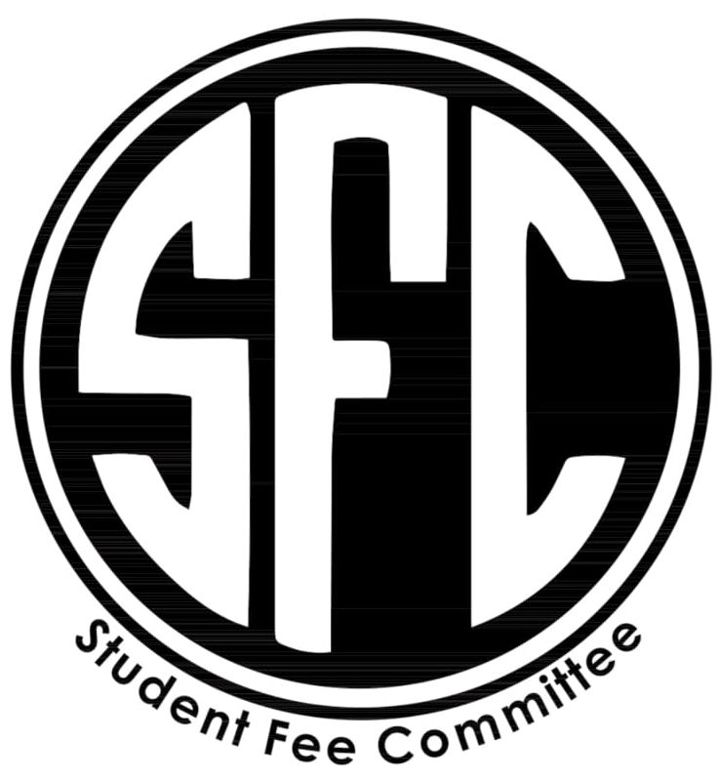
Student Fee Committee Agenda
January 8th, 2019
Taylor Graham - Chair
Crystal Binoeder - Vice Chair
Jordan Jones - Treasurer
Kurt Watne - Campus Development
JP Marshall - Secretary
McKenna Wright - Club Outreach
Kristen Martin - Advisor

12:00 - Admin Updates / Minute Review/
Taylor motioned to approve minuets
Kurt Moved the motion
Jordan seconded motion
Motion passed
6-0-0
Minutes approved
12:05 - Makenna spoke about the MLK day events and how to get clubs to attend.
Kristin gave input about her experience at PCC for service learning projects, which included cash incentives for clubs who attended.

Taylor made a motion that we use a tier system to award clubs with cash to attend MLK day event.

Motion passed
6-0-0
12:15 - Jeffery - Young life club
Pitched his club which will be a faith-based club aimed to spreading the message of Jesus through events that are non-threatening and available able to the student body.

Taylor makes motions
Kurt moved the motion
Jordan seconded the motion
Motion passed
6-0-0
Club chartered

12:20 - Kristen Spoke about visiting Corvallis and speaking with the club coordinator on main campus during our next trip to main campus.
12:25 - Discussion of student fees in preparation for Thursday’s meeting.
1:40 - Discussion about re-payment for hours worked in the counseling program that were not compensated by the University.
12:38 - Discussion of the EMDR training which cost $1000.00 dollars for the full event. Questions on how to get more students to take advantage of the professional development funds.
12:40 - Emily Carr
Requesting $950.00 in funds for social media marketing for a literary festival “Rendezvous with Risk”

Committee deliberated
Kurt requests that a change made from asc to sfc on their advertisements.

Taylor makes a motion to approve
Kurt moves the motion
Crystal seconded the motion

Motion passed
6-0-0
1:00 - discussion about the student success centered and the budget townhall.
Discussion of student fees continued.

Proposed increase to the student fees by $25.00 for 19/20 academic year.

1:20 - Rock Climbing Club Sport – Connor and Gabe
Pitching a club that will compete in rock climbing events. With a budget requesting 3500 to 5500

Taylor motions to allot the club $4500.00
Kurt moves the motion
Mckenna seconds the motions
Motion passes 6-0-0

Club was chartered
$4500.00 from unallocated funds.
1:30 -
Taylor makes a motion to close meeting
Kurt moves the motions
Mckenna seconds the motion
Meeting adjourned

