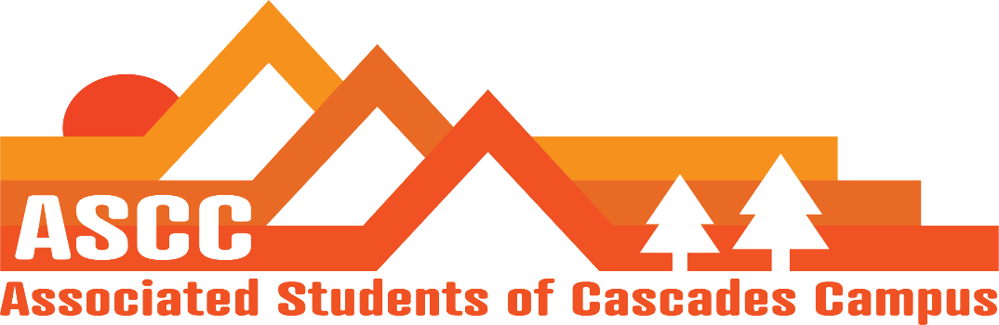
ASCC Meeting 2/13/2019 8:37 am
Brian
Cole
Cygnus
Reilly
Lynnea
Taylor
Tessa
Kristen (Advisor)

Cole
Overview of meeting minutes 2/6/2019. Motion passes 6-0-0
Lynnea
Lobby Day highlights. Fuel the vans up when returning vehicles. Representative Doroty, when it comes to capital tax, we must speak with representatives that fund our programs. Work with them to see if they would be with us for raising the taxes to fun higher education. Get Community leaders involved with supporting the SSC.
March 5th Lobby Day. Jordon Jones is on the books for constituent Betsy Johnson
Reilly
Has a meeting set up to talk with the head of the Honors College? Proposed an Honors College Association. We will be willing to accommodate an Honors College seat in ASCC. There are only 20 honors college students as of right now. Have not heard anything from Honors College up until this point. An honors student already have access to ASCC roles like every student on campus.

Taylor
Wrote memo with Reilly that goes to higher-ups for the student fee raise of $25.
Safer Sex initiative. Got approved. The proposal from Laurie Waters. Should do wall cabinets for some of the supplies instead of caddies due to limited space near the sinks. Wall units would provide safer storage. Need to coordinate with Nathan Moses for when non-students (school trips) come to visit the campus. Can begin ordering supplies. Will go ahead with caddies as of now and watch the program to see how it does.
Cygnus
OSA is on campus this week. Have meetings with them today.
Instead of class raps, group raps with clubs and attend club meetings could be a possible idea for lobbying initiatives.
OSA meeting updates – Tuition and police militarization bills are being worked on. Tuition equity bill is being worked on. Textbook affordability is going into meeting sessions.
Discussion on a Bill of lowering GPA requirements for community college acceptance. 2.5 Down to 2.0.
Kristen
The proposal from Kelly Sparks. City Affairs/ representation on City Council. Would like to propose 10 hours per week for next fall.

Important Dates:
Feb 18th – Winter Preview Day
March 5th – Lobby Day @ 6am-5pm
March 6-7: Elections information Session @ 1pm
March 15th: Elections Filing deadline @ 5 pm

Vote to end the meeting at 9:30 am. Motion passes 6-0-0.

