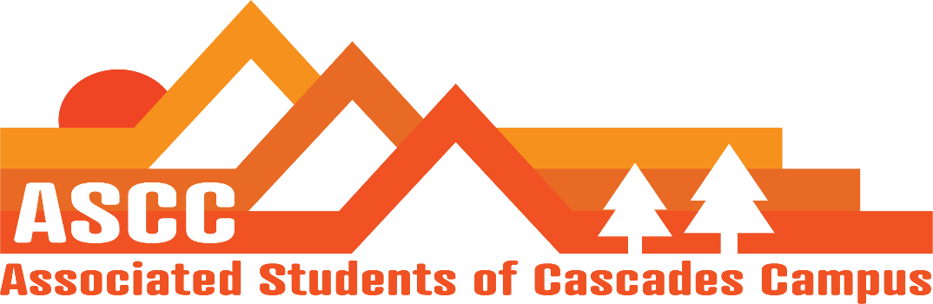
Meeting 4/10/2019 4pm
Brian
Cole
Lynnea
Reilly
Taylor
Tessa
Kristen (Advisor)

Cole
Approve Meeting Minutes from 4/5/2019. Motion passes 6-0-0.

Reilly
Elections/selections – Next week is voting for elections. Elections Committee will look over votes to ensure that all people who voted were Cascades students. 11:00pm. Selections. Changes have been made to the Constitution and Bylaws to add the two new ASCC positions.
Hiring Committee Training this Friday. 3-4 pm. Will be for election and selections.

Brian
Food pantry - Changing hours. 4:30 pm-5:30 pm on Tuesdays. Thursdays will be 11:30am-1:30 pm. Fridays will be 9:30am-10: 30 am. Working on getting connected with Locavore for a partnership for Diversity Week. Locavore has vegan options which we currently do not have. Meeting with HDFS graduate students to discuss working on creating a foundation account for the Food Pantry.
Child Care Subsidy - No applications have been turned in as of right now. Has had four responses stating that they will be turned in, but need more time.

Tessa
PR Update – Pictures. Marketing is requesting new photos for new Cascades gear.
Tabeling for elections schedule. Propose ASCC members covering a couple of hours in the Dining Hall for elections voting. Rent laptops from the library.
Damn Proud Day. Fundraising event aimed at community members and alumni. Looking to involve current students to donate. Five giving opportunities. The minimum is $5. Vote to abstain Damn Proud Day. Motion passes 6-0-0.

Lynnea
April 17th All OSU Lobby Day.
Kaylee’s Law passed 7-0.
OSA was on campus this week. Met with Tori, the interim director. The meeting was positive and engaging as meetings have been in the past. Was given information on the new OSA Training Catalog. Tori will be back for Diversity Week.
OSERA Symposium will be at Corvallis campus. $75 for early registration. $85 for regular admission. One day only workshops.
Kristen
Variety Show this Friday. 6:30 pm-8pm
Important Dates
April 17: All OSU Lobby Day
April 26: Budget Hearing
May 6: State of the University @ 6 pm @ Bend Riverhouse
May 18: Pole, Pedal, Paddle
May 23: Research Symposium
May 31-June 2: TBD Transition Retreat
June 6: Leadership Banquet
June 14: Senior Send-Off
Vote to end meeting at 5:01 pm. Motion passes 6-0-0.

