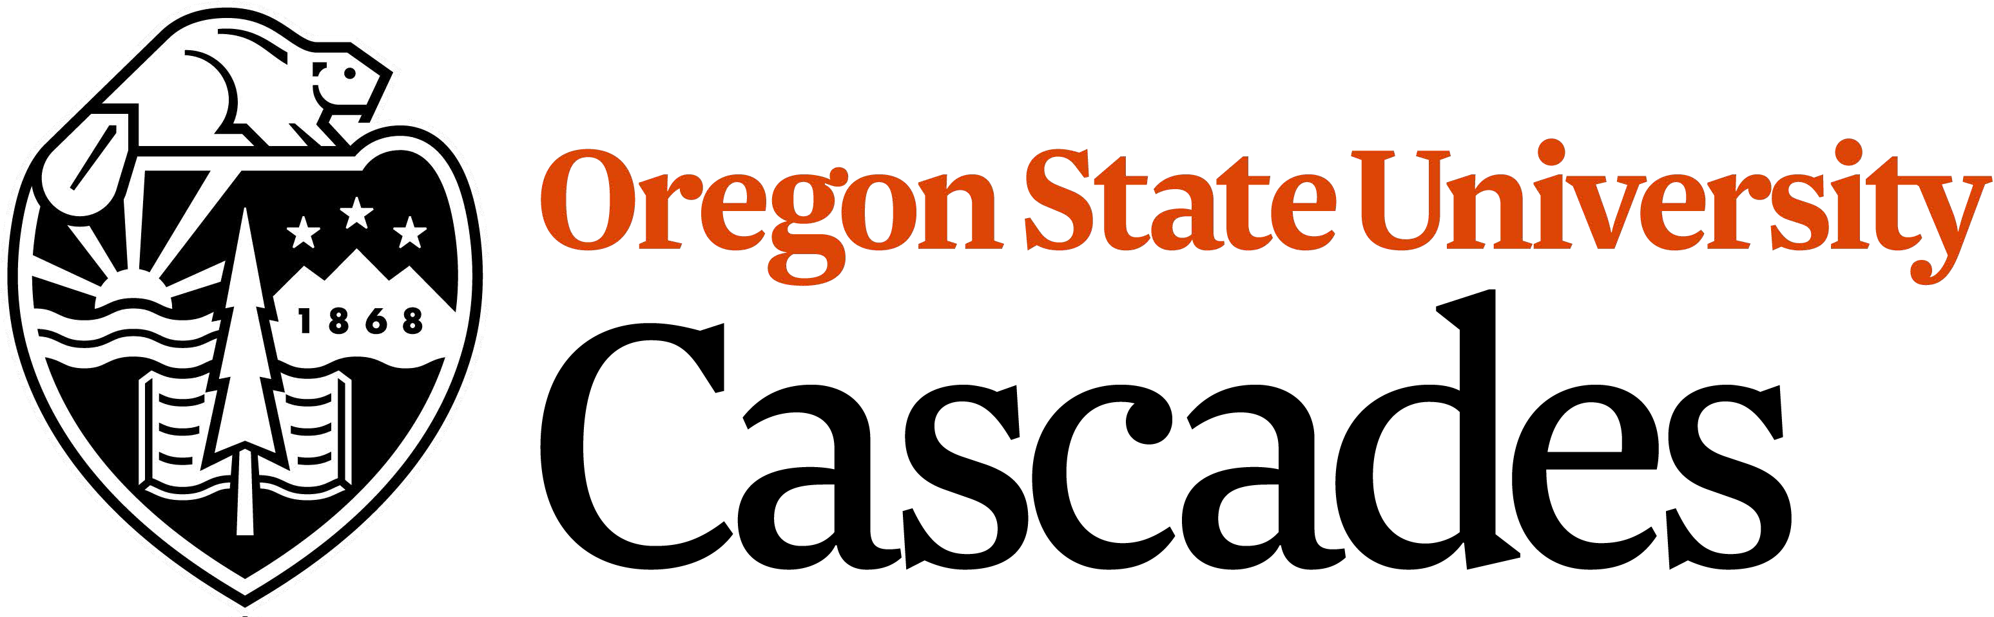

Hospitality Management Exploratory Student Scholarship

Purpose: The scholarship fund was established to build a sustainable workforce in the hospitality industry by attracting new students to the hospitality management program at OSU.

Administration: The scholarship is funded by the existing Robin and Curt Baney Endowment. A Hospitality Management Scholarship Committee made up of faculty and staff who interact with students as part of their job, will review the student scholarship applications and award the students based on available funds and the criteria set forth below.

Awards: The scholarship has $15,000 in total available funds for the 2022 academic year and will award a maximum of $1,000 to individual students. To receive the scholarship, apply today.

In the event, there is not an adequate amount of qualified applications; the Hospitality Management Scholarship Committee has the discretion to raise the maximum award amount per student. Any unused funds will be returned to the annual endowment fund to support future awards.

Scholarship Criteria: The objective is to identify students who:
- Currently enrolled or admitted to OSU
- Demonstrated financial need in application (statement in application)
- Demonstrated willingness to explore hospitality industry as potential career (statement in application) and not currently enrolled as an HM Major

Application process: The objective is to identify students who meet or exceed the scholarship criteria.

Students submit:
- The 3-page form below with responses to each of the questions.
- A completed FERPA Scholarship Release of Information form.

Submit application to Todd Montgomery (montgomt@oregonstate.edu).

Application Due Date: December 1, 2021
Award Date: January 1, 2022

Publication and Reporting: Once the scholarships are awarded, each student will be notified in writing with a copy of the award notification sent to the Hospitality Management Committee. At the end of the academic year, the committee will also receive a letter confirming the distribution of funds to the students.

Awardee Obligations: All students who receive an award are required to send a personal thank you letter. This thank you letter should express their gratitude for the award and how these funds will help them pursue their professional aspirations in the hospitality management industry.

FERPA Scholarship Release of Information
In accordance with the Family Educational Rights and Privacy Act of 1974 (FERPA), I, the undersigned, hereby give my consent to Oregon State University to release education records or personal information to individuals or entities to whom I have applied for a fellowship or who have awarded me a fellowship ("Recipients"). I consent to the disclosure of any and all education records and personal information that is needed by Recipients to evaluate, award, renew, update, maintain or administer my fellowship or fellowship application. These records and information include, but are not limited to, application information (resume, letter, etc.), GPA, year in school, financial need, and major field of study. Personal information may be re-disclosed by Recipients only as needed for their own stewardship or grant request purposes and will otherwise remain confidential. My name, image, and directory student information may be shared in any media release publicizing the scholarship. I understand further that:

- I have the right not to consent to the release of my education records and I understand that my refusal to consent may jeopardize my eligibility for some scholarships;
- I have the right to receive a copy of such records upon request;
- This consent shall remain in effect until revoked by me.

Submission of this Fellowship Application confirms my choice to consent to, or to withhold my consent from, this FERPA Release.

THIS INFORMATION IS RELEASED PURSUANT TO THE CONFIDENTIALITY PROVISIONS OF FERPA AND OTHER APPROPRIATE STATE AND FEDERAL LAWS AND REGULATIONS, WHICH PROHIBIT ANY FURTHER DISCLOSURE OF THIS INFORMATION WITHOUT THE SPECIFIC WRITTEN CONSENT OF THE PERSON TO WHOM IT PERTAINS, OR AS OTHERWISE PERMITTED BY SUCH REGULATIONS.

I indicate whether I consent to the FERPA information release by my choice to give, or withhold, my authorization: I have read and agree to the above terms and conditions.
I Give Consent I Withhold Consent

Signature Date

Print Name Student ID Number

G e n e r a l I n f o r m a t i o n
This is a fillable form

Last First MI Student ID Number

Street City State Zip Telephone Number

GPA – Overall

GPA – OSU-Cascades

- Briefly describe how the scholarship will contribute to your future education and career goals [200 word limit]:

- Discuss why you are interested in the hospitality industry and how you will utilize your degree in your professional career: [200 word limit]:

