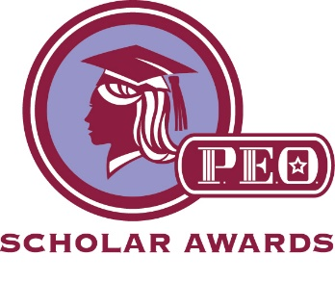
P.E.O. is a Philanthropic Education Organization where women celebrate the advancement of women, educate women through scholarships, and motivate women to achieve their highest aspirations.

The AI Bend Chapter of P.E.O. is seeking applicants for the following scholarships for the 2021-2022 academic year. The applications will be due by March 1, 2021. In order to complete our selection process, the deadline to notify us of your interest is Friday, October 30, 2020.

Oregon Marguerite: Provides grants for tuition and fees applied toward a degree, certificate, workshop, vocational or technical course, specialized training at any post-secondary level of an accredited institution in Oregon. Fees, books, and other expenses such as childcare and transportation may be covered if school fees are paid. Award amounts dependent on need and funds available.
Qualifications:
- U.S. Citizen, resident of Oregon, and attending an Oregon institution.
- Preference will be given to a woman re-entering school after a significant break in education, those with dependents, and successfully enrolled in school rather than an incoming freshman.
- Extenuating circumstances will be considered.
- Six credit hours minimum completed with a minimum of 2.5 GPA required.

Oregon Scholarship: Provides grants for tuition and fees to women pursuing a degree at an accredited Oregon college or university. Award amounts dependent upon funds available.
Qualifications:
- U.S. Citizen and resident of Oregon
- Junior, Senior, or graduate student at accredited Oregon college or University. If you are currently a sophomore, you would be eligible if you are accepted at an accredited Oregon college by March 1, 2021.
- Ninety (90) credit hours completed at quarter institutions or sixty (60) credit hours completed at semester institutions, pursuing a solid degree.
- Minimum 2.5 GPA required
- Funding available only for the next academic year and applicant cannot receive Marguerite funds in the same academic year.

Questions and Application Process:
- Send an email of interest and/or questions to Sharon Lichti, slichti@bendcable.com by October 30, 2020.
- AI Chapter will review and interview the applicants during November and December 2020.
- An AI Chapter Education Committee member will assist in the completion of the application to be submitted by the deadline date of March 1, 2021.

